## PROGRAM DEFINITION

|  |
| --- |
|  |
| * Program untuk generate Reversing Journal berdasarkan Reversing Journal Master |

## RELATED TABLES

|  |  |
| --- | --- |
|  | **Access** |
| * GLT_TRANS_HD * GLT_TRANS_JRN * GLA_ACCOUNT_BALANCE * GSM_COA * GSM_CENTER * GSM_COMPANY * GSM_DEPARTMENT * GSM_CURRENCY * GSM_CURRENCY_RATE * GLM_SYSTEM_PARAM | * RW * RW * RW * RW * RW * R * R * R * R * R * R * R |

## ROLES

|  |  |
| --- | --- |
|  | **Test** |
| * User yg mempunyai akses ke program |  |

## INITIAL PROCESS

|  |  |
| --- | --- |
|  | **Test** |
| * Set VAR_COMPANY_ID = Login User’s Company ID * Set VAR_USER_ID = Login User ID * Set VAR_LANGUAGE_ID = Login User’s Language ID * Set VAR_TODAY = Get Property Date dengan function dbo.RFN_GET_DB_TODAY(VAR_COMPANY_ID) * Jalankan query berikut, simpan hasil ke VAR_GSM_COMPANY  SELECT CBASE_CURRENCY_CODE   ,CLOCAL_CURRENCY_CODE  FROM GSM_COMPANY (NOLOCK) WHERE CCOMPANY_ID = VAR_COMPANY_ID * Jalankan RSP_GL_GET_SYSTEM_PARAM dengan parameter, simpan hasil ke VAR_GL_SYSTEM_PARAM   + VAR_COMPANY_ID * Jalankan RSP_GS_GET_DEPT_LOOKUP_LIST dengan parameter, simpan hasil ke VAR_USER_DEPARTMENT_LIST   + VAR_COMPANY_ID   + VAR_USER_ID * Jalankan query berikut, simpan hasil ke VAR_GSM_TRANSACTION_CODE  SELECT LINCREMENT_FLAG  ,LAPPROVAL_FLAG  FROM GSM_TRANSACTION_CODE (NOLOCK) WHERE CCOMPANY_ID = VAR_COMPANY_ID AND CTRANSACTION_CODE=’000030’ |  |

## REVERSING JOURNAL LIST

### USER INTERFACE

#### INITIAL VERSION

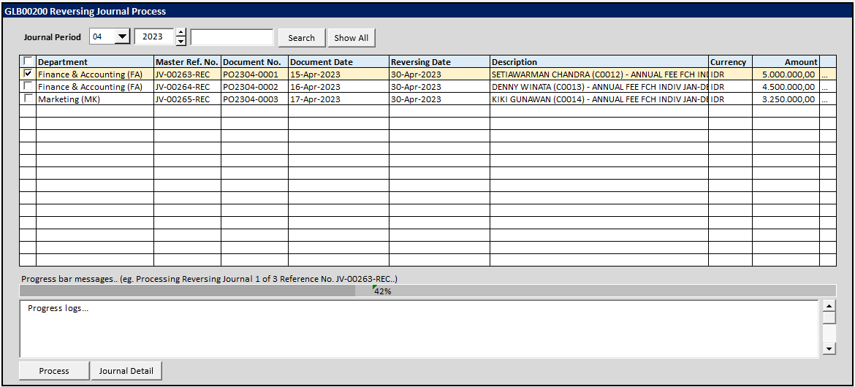

### BUTTON DEFINITION

|  |  |
| --- | --- |
| **Button Name** | **Action** |
| Search | Jalankan SEARCH PROCESS |
| Show All | Jalankan SHOW ALL PROCESS |
| Process | Jalankan REVERSING JOURNAL PROCESS |
| Journal Detail | Jalankan POPUP JOURNAL DETAIL |
|  |  |
|  |  |

### OUTPUT

|  |  |
| --- | --- |
|  | **Test** |
|  |  |

### ROLES

|  |  |
| --- | --- |
|  | **Test** |
| * User yg punya akses ke program |  |

### INITIAL PROCESS

|  |  |
| --- | --- |
|  | **Test** |
|  |  |

### DISPLAY PROCESS

#### FIELD DEFINITION

|  |  |  |  |
| --- | --- | --- | --- |
| **Name** | **Field** | **Type** | **Validation** |
| Journal Period (Month) |  | Combobox  Isi combo box value dengan  01 s/d 12  Set Default selected value = Current Month |  |
| Journal Period (Year) |  | Spinner   * Minimum Value = VAR_GSM_PERIOD.IMIN_YEAR * Maximum Value = VAR_GSM_PERIOD.IMAX_YEAR * Stepping value = 1   Set Default selected value = Current Year |  |
| Search textbox |  | Textbox | Maximum 20 karakter |
| Progress bar message |  | Label |  |
| Progress Bar |  | Progress Bar |  |
| Progress Logs |  | Textarea |  |

#### JOURNAL GRID DEFINITION

|  |  |  |  |
| --- | --- | --- | --- |
| **Name** | **Field** | **Type** | **Validation** |
| Journal ID | CREC_ID | Hidden |  |
| Valid Flag | LVALID | Hidden |  |
| Department Code | CDEPT_CODE | Hidden |  |
| Record Selector |  | Checkbox | IF LVALID=1 THEN Enabled ELSE Disabled |
| Department | CDEPT_CODE_NAME | Label |  |
| Master Ref. No. | CREF_NO | Label |  |
| Document No. | CDOC_NO | Label |  |
| Document Date | CDOC_DATE | Label |  |
| Seq. | ISEQUENCE | Label |  |
| Start Date | CSTART_DATE | Label |  |
| Next Date | CNEXT_DATE | Label |  |
|  |  |  |  |
| Description | CTRANS_DESC | Label |  |
| Currency | CCURRENCY_CODE | Label |  |
| Amount | NTRANS_AMOUNT | Label |  |
| Local Currency | CLOCAL_CURRENCY_CODE | Label |  |
| Local Amount | NLTRANS_AMOUNT | Label |  |
| Base Currency | CBASE_CURRENCY_CODE | Label |  |
| Base Amount | NBTRANS_AMOUNT | Label |  |
| Grid Mode   * Read Only for all columns except record selector. * IF LVALID=0 THEN Set row background color to RED | | | |
|  |  |  |  |
|  | | | |

#### BUTTON MODE

|  |  |
| --- | --- |
| **Button Name** | **Mode** |
| Search | Enabled |
| Show All | Enabled |
| Process | IF has data in JOURNAL GRID THEN Enabled ELSE Disabled |
| Journal Detail | IF has data in JOURNAL GRID THEN Enabled ELSE Disabled |
|  |  |
|  |  |

### SEARCH PROCESS

#### VALIDATION

|  |  |  |
| --- | --- | --- |
| **Field** | **Condition** | **Validation Message** |
| Search text | Empty | Please input keyword to search! |
|  | Not Empty  AND  Input length < 3 | Minimum search keyword is 3 characters! |

#### ACTION

|  |
| --- |
|  |
| * Refresh Journal Grid dengan RSP_GL_SEARCH_ACTIVE_REVERSING_LIST dengan parameter, simpan hasil ke VAR_RESULT   + VAR_COMPANY_ID   + VAR_USER_ID   + Selected Journal Period dengan format YYYYMM   + Input Search Text   + VAR_LANGUAGE_ID * IF VAR_RESULT empty,   + Display message “No data found!” |

### SHOW ALL PROCESS

#### VALIDATION

|  |  |  |
| --- | --- | --- |
| **Field** | **Condition** | **Validation Message** |
|  |  |  |

#### ACTION

|  |
| --- |
|  |
| * Refresh Journal Grid dengan RSP_GL_SEARCH_ACTIVE_REVERSING_LIST dengan parameter, simpan hasil ke VAR_RESULT   + VAR_COMPANY_ID   + VAR_USER_ID   + Selected Journal Period dengan format YYYYMM   + ‘’ (Empty String)   + VAR_LANGUAGE_ID * IF VAR_RESULT empty   + Display message “No data found!” |

### REVERSING JOURNAL PROCESS

#### VALIDATION

|  |  |  |
| --- | --- | --- |
| **Field** | **Condition** | **Validation Message** |
| Record Selector | No Record Selected | Please select Recurring Journal to process! |
| VAR_GSM_TRANSACTION_CODE.LINCREMENT_FLAG | 0 | Cannot process Recurring Journal with Manual Numbering! Transaction numbering setting for Recurring Journal should be auto increment, not manual numbering! |

#### ACTION

|  |
| --- |
|  |
| * Display confirmation message “Are you sure want to process selected Reversing Journal(s)?” [Yes/No] * IF No THEN   + Kembali ke form * Set VAR_DATA_COUNT=Number of selected Data in grid * Reset Progress Bar Messages, Progress Bar and Progress Logs * Setting Progress Bar (**KONTAK SAYA UNTUK CARA PEMAKAIAN LIBRARY PROGRESS BAR!**) * Add message “Start Processing Reversing Journal” to Progress Logs * Process Selected Recurring Journal 1 by 1   + Add message “Processing Master Ref. No. CREF_NO[N]” to Progress Logs   + Update Progress Bar Message “Processing data N of VAR_DATA_COUNT   + Jalankan RSP_GL_PROCESS_REVERSING_JRN dengan parameter     - VAR_COMPANY_ID     - VAR_USER_ID     - Selected Data[N].CDEPT_CODE     - Selected Data[N].CREF_NO     - Selected Data[N].CREC_ID   + IF Error     - Add message “Failed to process Master Ref. No. CREF_NO[N]: [ERROR_MESSAGES]!” to Progress Logs     - Add message “Processing Master Ref. No. CREF_NO[N]: FAILED!” to Progress Logs   + ELSE     - Add message “Processing Master Ref. No. CREF_NO[N]: SUCCESSFUL!” to Progress Logs   + Update Progress Bar Message (**KONTAK SAYA UNTUK CARA PEMAKAIAN LIBRARY PROGRESS BAR!**)   + Update Progress Bar (**KONTAK SAYA UNTUK CARA PEMAKAIAN LIBRARY PROGRESS BAR!**) * Add message “Finish Processing Reversing Journal!” to Progress Logs * Refresh JOURNAL GRID |

## POPUP JOURNAL DETAIL

### USER INTERFACE

#### INITIAL VERSION

### BUTTON DEFINITION

|  |  |
| --- | --- |
| **Button Name** | **Action** |
| Close | Tutup form |
|  |  |
|  |  |

### OUTPUT

|  |  |
| --- | --- |
|  | **Test** |
|  |  |

### ROLES

|  |  |
| --- | --- |
|  | **Test** |
| * Admin |  |

### INITIAL PROCESS

|  |  |
| --- | --- |
|  | **Test** |
| * Refresh JOURNAL DETAIL Grid dengan RSP_GL_GET_JOURNAL_DETAIL_LIST dengan parameter   + Selected Journal->CREC_ID   + VAR_LANGUAGE_ID |  |

### DISPLAY PROCESS

#### FIELD DEFINITION

|  |  |  |  |
| --- | --- | --- | --- |
| **Name** | **Field** | **Type** | **Validation** |
| Reference No. | Selected Journal-> CREF_NO | Textbox, disabled |  |
| Amount | Selected Journal -> NTRANS_AMOUNT | Textbox, disabled |  |
| Status |  | Textbox, disabled  Set value=Submitted |  |

#### JOURNAL DETAIL GRID DEFINITION

|  |  |  |  |
| --- | --- | --- | --- |
| **Name** | **Field** | **Type** | **Validation** |
| Journal Detail ID | CREC_ID | Hidden |  |
| No. | INO | Label |  |
| Account No. | CGLACCOUNT_NO | Label |  |
| Account Name | CGLACCOUNT_NAME | Label |  |
| Center | CCENTER_NAME | Label |  |
| D/C | CDBCR | Label |  |
| Debit | NDEBIT | Label | IF CDBCR=D THEN displayed ELSE Hidden |
| Credit | NCREDIT | Label | IF CDBCR=C THEN displayed ELSE Hidden |
| Description | CDETAIL_DESC | Label |  |
| Grid Mode   * Read Only | | | |
|  |  |  |  |

#### BUTTON MODE

|  |  |
| --- | --- |
| **Button Name** | **Mode** |
| Approve | IF has data in Grid THEN Enabled ELSE disabled |
| Cancel | Enabled |
|  |  |

# CR LIST

|  |  |  |
| --- | --- | --- |
| **CR** | **Description** | **Notes** |
| 00  02-May-2023 | * INITIAL VERSION |  |
|  |  |  |
|  |  | </CR2> |
|  |  |  |

#### TEMPLATE

#### VALIDATION

|  |  |  |
| --- | --- | --- |
| **Field** | **Condition** | **Validation Message** |
|  |  |  |
|  |  |  |

#### ACTION

|  |
| --- |
|  |
|  |

Backup

* + IF VAR_RECURRING_JRN.CCURRENCY_CODE <> VAR_GSM_COMPANY.CBASE_CURRENCY_CODE OR VAR_RECURRING_JRN.CCURRENCY_CODE <> VAR_GSM_COMPANY.CLOCAL_CURRENCY_CODE
    - Jalankan RSP_GS_GET_LAST_CURRENCY_RATE dengan parameter, simpan hasil ke VAR_LAST_CURRENCY_RATE
      * VAR_COMPANY_ID
      * VAR_RECURRING_JRN.CCURRENCY_CODE
      * VAR_GL_SYSTEM_PARAM.CRATETYPE_CODE
      * VAR_RECURRING_JRN.CNEXT_DATE
    - IF VAR_LAST_CURRENCY_RATE is EMPTY
      * Display Message “Currency Rate not found for Master Ref. No. SelectedData[N].CREF_NO, skip processing!”
      * Add message “Failed to process Reference No. CREF_NO[N]: Currency Rate not found!” to Progress Logs
      * Add message “Processing Reference No. CREF_NO[N]: FAILED!” to Progress Logs
      * Skip and continue processing Next Data